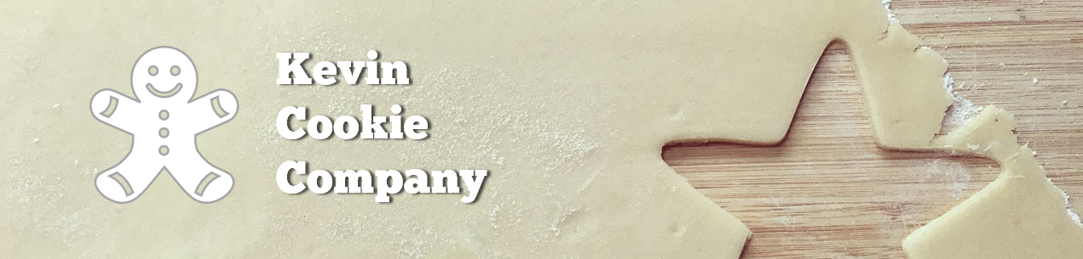

Cookie Order Form

|  |  |  |
| --- | --- | --- |
| Order Number: | 849875 | |
| Your Full Name: | Jerry Shaw | |
| Cookie Type & Quantity: | Chocolate Chip | 6 |
| How did you hear about us? | Newspaper Ad | |
| Preferred Delivery Method: | Express Package | |
| Desired Delivery Date: | 2/11/2021 | |

We appreciate your business!